**SOC Level 1**

**Junior Security Analyst Intro**

**Task 1:**

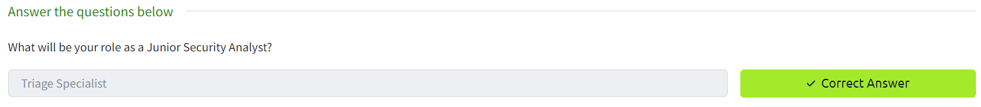

**Task 2:**

No need to submit

**Task 3:**

